Install Prometheus and Grafana on a Linux EC2 machine, connect Prometheus to Grafana, and create a dashboard to view metrics.

Step 01: Installing Grafana

Step 02: Installing Prometheus

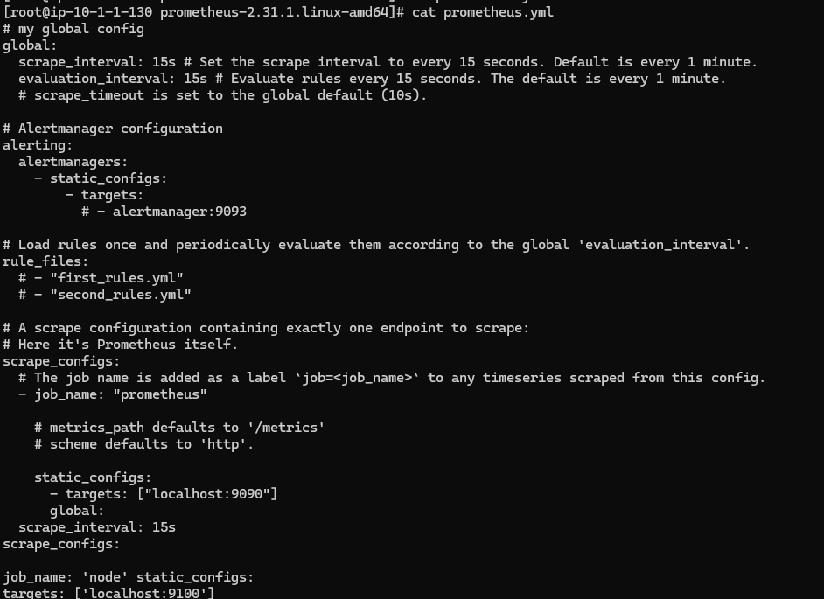

Step 03: Installing Node Explorer

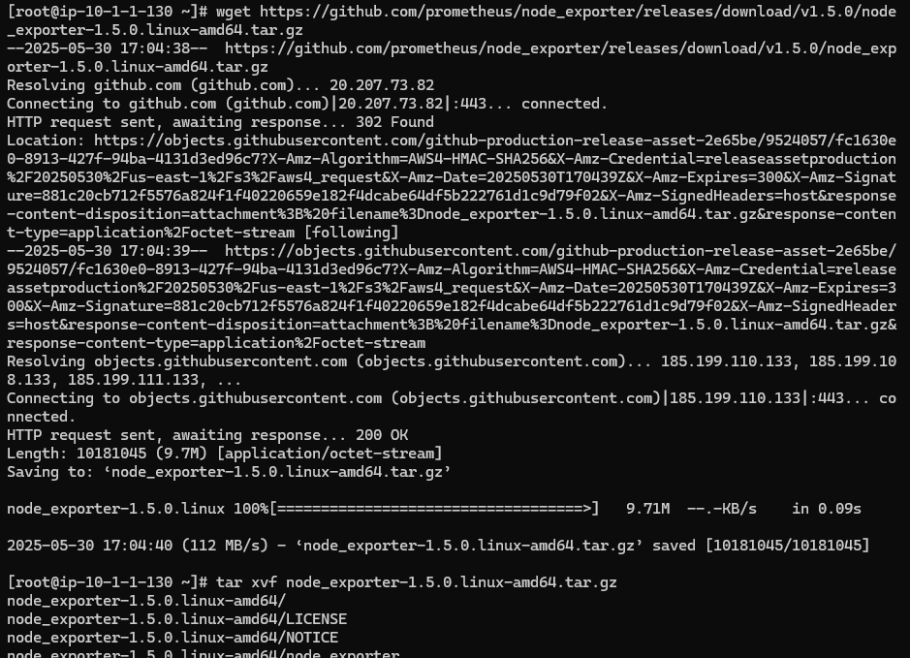

**Step 05:** Creating Dashboard

